1. Create a function that takes a list and returns a new list containing only prime numbers.

**Examples**

filter_primes([7, 9, 3, 9, 10, 11, 27]) ➞ [7, 3, 11]

filter_primes([10007, 1009, 1007, 27, 147, 77, 1001, 70]) ➞ [10007, 1009]

filter_primes([1009, 10, 10, 10, 3, 33, 9, 4, 1, 61, 63, 69, 1087, 1091, 1093, 1097]) ➞ [1009, 3, 61, 1087, 1091, 1093, 1097]

def filter_primes(in_list):

a=[]

for i in in_list:

if i <=1:

continue

else:

for j in range(2,i):

if i % j == 0:

break

else:

a.append(i)

print(f"{in_list} --> {a}")

filter_primes([7, 9, 3, 9, 10, 11, 27])

2. Once a water balloon pops, is soaks the area around it. The ground gets drier the further away you travel from the balloon.

The effect of a water balloon popping can be modeled using a list. Create a function that takes a list which takes the pre-pop state and returns the state after the balloon is popped. The pre-pop state will contain at most a single balloon, whose size is represented by the only non-zero element.

**Examples**

pop([0, 0, 0, 0, 4, 0, 0, 0, 0]) ➞ [0, 1, 2, 3, 4, 3, 2, 1, 0]

pop([0, 0, 0, 3, 0, 0, 0]) ➞ [0, 1, 2, 3, 2, 1, 0]

pop([0, 0, 2, 0, 0]) ➞ [0, 1, 2, 1, 0]

pop([0]) ➞ [0]

def pop(in_list):

lth = len(in_list)//2

fw=bw=lth

while(bw>0):

in_list[fw]=lth

in_list[bw]=lth

bw-=1

fw+=1

lth-=1

return in_list

print(pop([0, 0, 0, 0, 4, 0, 0, 0, 0]))

3. "Loves me, loves me not" is a traditional game in which a person plucks off all the petals of a flower one by one, saying the phrase "Loves me" and "Loves me not" when determining whether the one that they love, loves them back.

Given a number of petals, return a string which repeats the phrases "Loves me" and "Loves me not" for every alternating petal, and return the last phrase in all caps. Remember to put a comma and space between phrases.

**Examples**

loves_me(3) ➞ "Loves me, Loves me not, LOVES ME"

loves_me(6) ➞ "Loves me, Loves me not, Loves me, Loves me not, Loves me, LOVES ME NOT"

loves_me(1) ➞ "LOVES ME"

def loves_me(in_num):

output=[]

for ele in range(in_num):

if ele%2==0:

output.append("Loves me")

else:

output.append("Loves me not")

output[-1] = output[-1].upper()

print('"'+' , '.join(output)+'"')

loves_me(1)

4. Write a function that sorts each string in a list by the letter in alphabetic ascending order (a-z).

**Examples**

sort_by_letter(["932c", "832u32", "2344b"])

➞ ["2344b", "932c", "832u32"]

sort_by_letter(["99a", "78b", "c2345", "11d"])

➞ ["99a", "78b", "c2345", "11d"]

sort_by_letter(["572z", "5y5", "304q2"])

➞ ["304q2", "5y5", "572z"]

sort_by_letter([])

➞ []

def sort_by_letter(in_list):

temp_list = []

output = []

for ele in in_list:

for char in ele:

if char.isalpha():

temp_list.append(char)

temp_list.sort()

for char in temp_list:

for ele in in_list:

if char in ele:

output.append(ele)

print(f'sort_by_letter({in_list}) ----> {output}')

sort_by_letter(["932c", "832u32", "2344b"])

sort_by_letter(["99a", "78b", "c2345", "11d"])

sort_by_letter(["572z", "5y5", "304q2"])

sort_by_letter([])

5. There are three cups on a table, at positions A, B, and C. At the start, there is a ball hidden under the cup at position B.

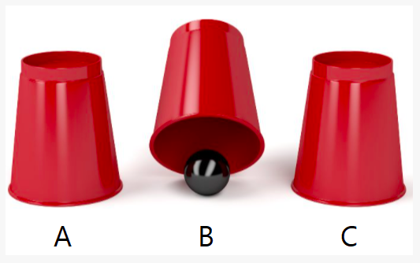

However, I perform several swaps on the cups, which is notated as two letters. For example, if I swap the cups at positions A and B, I could notate this as AB or BA.

Create a function that returns the letter position that the ball is at, once I finish swapping the cups. The swaps will be given to you as a list.

**Example**

cup_swapping(["AB", "CA", "AB"]) ➞ "C"

# Ball begins at position B.

# Cups A and B swap, so the ball is at position A.

# Cups C and A swap, so the ball is at position C.

# Cups A and B swap, but the ball is at position C, so it doesn't move.

def cup_swapping(swap_list,initial_ball_pos):

ball_pos = initial_ball_pos

for swap in swap_list:

if ball_pos in swap:

ball_pos=swap.replace(ball_pos,"")

print(ball_pos)

cup_swapping(["AB", "CA", "AB"],'B')